**SQL Query Analysis**

1. **To import excel data into sql create table with column names and data types.**

CREATE TABLE coffee (

id SERIAL PRIMARY KEY,

date DATE,

day VARCHAR(10),

month VARCHAR(10),

datetime TEXT,

hour TEXT,

cash_type VARCHAR(10),

card TEXT,

money NUMERIC,

coffee_name VARCHAR(50)

);

**2. View overall data all rows**

select * from coffee;

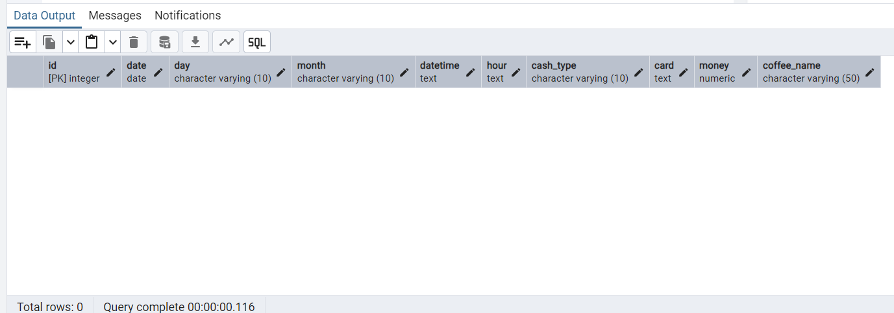

1. **To import data from excel to sql .**

COPY coffee

FROM 'C:\Users\Sandhya\OneDrive\Desktop\Coffee_Sales Analysis Project\coffee.csv'

DELIMITER ','

CSV HEADER;

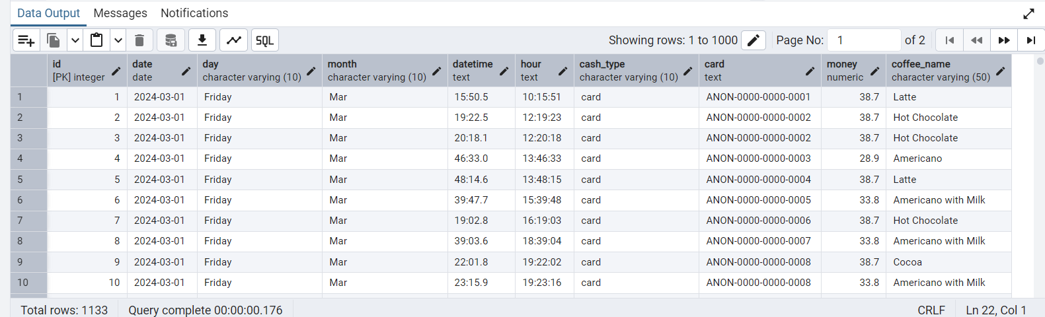

**3. View Raw data first 10 rows**

SELECT * FROM coffee LIMIT 10;

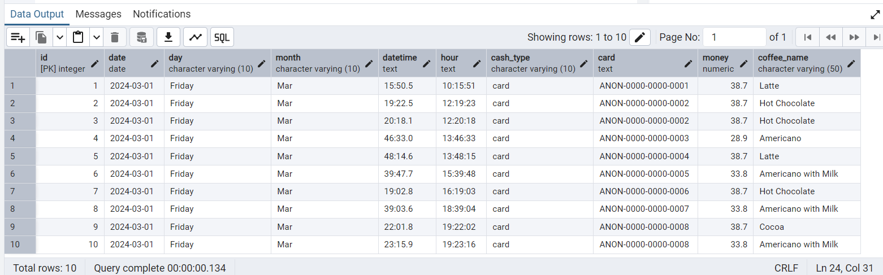

**4. Check for NULLS**

-- Empty strings or nulls in important fields

SELECT * FROM coffee

WHERE TRIM(card) = '' OR card IS NULL

OR TRIM(cash_type) = '' OR cash_type IS NULL;

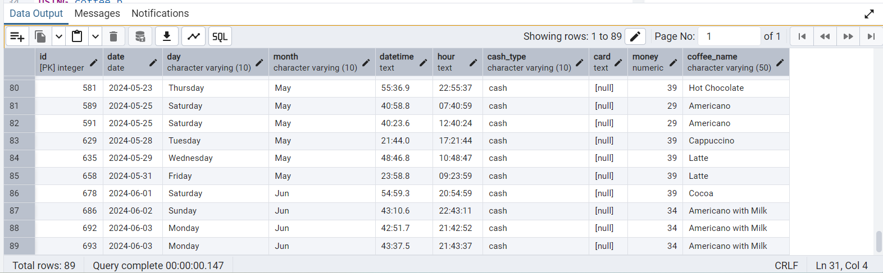

**5. Remove Duplicates (if applicable)**

DELETE FROM coffee a

USING coffee b

WHERE

a.id < b.id AND

a.datetime = b.datetime AND

a.coffee_name = b.coffee_name AND

a.money = b.money;

**6. To remove rows where the card column is NULL from the coffee table**

DELETE FROM coffee

WHERE card IS NULL;

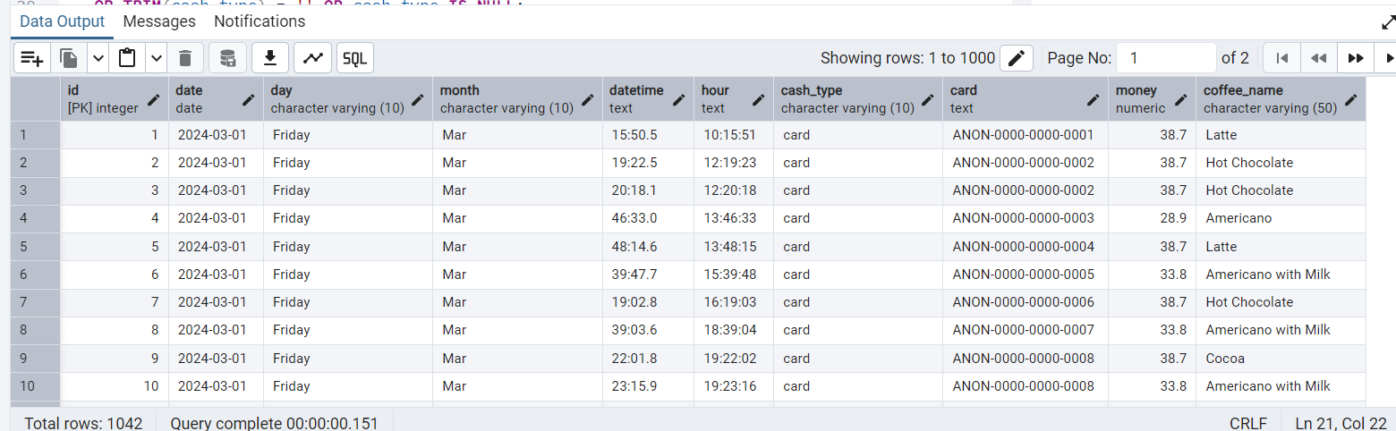

**7. Total sales per coffee type**

SELECT coffee_name, SUM(money) AS total_sales

FROM coffee

GROUP BY coffee_name

ORDER BY total_sales DESC;

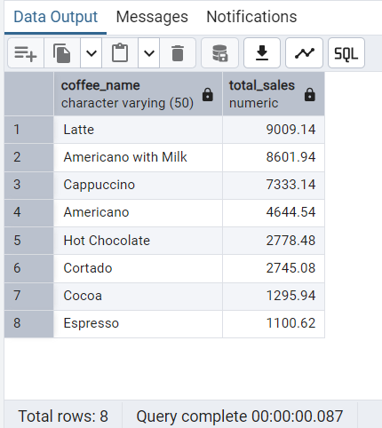

**8. Daily sales summary**

SELECT date, SUM(money) AS total_sales, COUNT(*) AS cups_sold

FROM coffee

GROUP BY date

ORDER BY date;

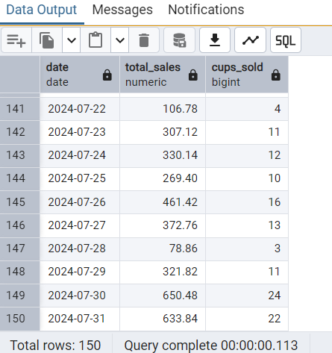

**9. Sales by payment type**

SELECT cash_type, COUNT(*) AS transactions, SUM(money) AS total

FROM coffee

GROUP BY cash_type;

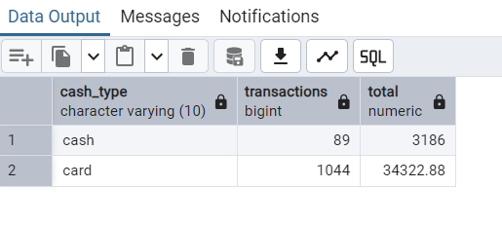

**10. Peak sales hours**

SELECT hour, COUNT(*) AS total_orders, SUM(money) AS revenue

FROM coffee

GROUP BY hour

ORDER BY revenue DESC;

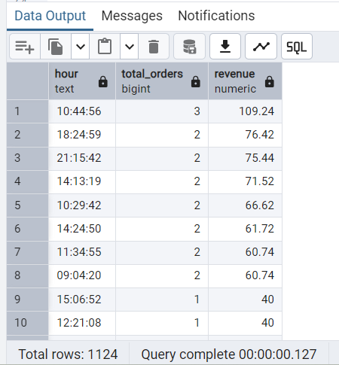

**11. Monthly sales trend (assuming date is used)**

SELECT TO_CHAR(date, 'Month') AS month, SUM(money) AS total_sales

FROM coffee

GROUP BY TO_CHAR(date, 'Month')

ORDER BY MIN(date);

